LECTURE 3.3.3
TREES
Course outcome to be covered:
CO4: Apply and recognized about the Trees

1.1 TRAVERSING BINARY TREES
In this lecture we will study the methods to traverse a binary tree. The different types of binary trees have been discussed in the previous lecture. We will continue the topic of binary trees now.
1.2 TOPIC OBJECTIVES:
- In this topic the students will learn standard methods to traverse binary trees.
- This lecture will help students to the preorder, post order and in order traversing of binary trees.
1.3 STRUCTURE:
- Introduction
- Traversing binary trees
- Pre order traversal
- Post order traversal
- In order traversal
- Algorithm to draw binary trees
- Algorithm to convert general tree into binary
1.4 INTRODUCTION
In our previous lectures we introduced trees and the different types of trees with specific properties. A special type of tree called the binary tree is very important which was defined in the last lecture with specific categories. Now we will learn to traverse these binary trees in different orders.
1.5 TRAVERSING BINARY TREES
Traversing a binary tree means to visit all the nodes of the tree. There are three standard methods to traverse the binary trees. When we wanted to display a binary tree, we need to follow some order in which all the nodes of that binary tree must be displayed. In any binary tree, displaying order of nodes depends on the traversal method. These are as follows:
- Preorder Traversal
- Post order Traversal
- In order Traversal
1. Preorder Traversal: The preorder traversal of a binary tree is a recursive process. The preorder traversal of a tree is
- Visit the root of the tree.
- Traverse the left sub tree in preorder.
- Traverse the right sub tree in preorder.
2. Post order Traversal: The post order traversal of a binary tree is a recursive process. The post order traversal of a tree is
- Traverse the left sub tree in post order.
- Traverse the right sub tree in post order.
- Visit the root of the tree.
3. In order Traversal: The in order traversal of a binary tree is a recursive process. The in order traversal of a tree is
- Traverse in In order the left sub tree.
- Visit the root of the tree.
- Traverse in In order the right sub tree.
Example: Determine the preorder, post order and in order traversal of the binary tree as shown in fig1 below:
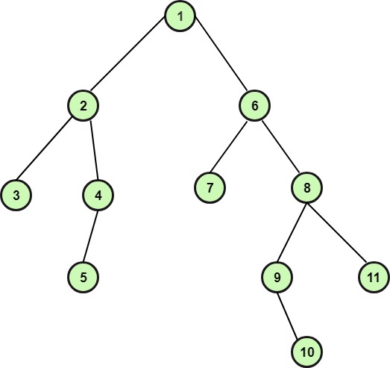

Fig 1
Solution: The preorder, post order and in order traversal of the tree is as follows table 1.a
Preorder | 1 | 2 | 3 | 4 | 5 | 6 | 7 | 8 | 9 | 10 | 11
Post order | 3 | 5 | 4 | 2 | 7 | 10 | 9 | 11 | 8 | 6 | 1
In order | 3 | 2 | 5 | 4 | 1 | 7 | 6 | 9 | 10 | 8 | 11
Table 1.a
EXAMPLE: Consider the given binary tree in fig 2 below, write the in order, pre order and post order transversal for it.
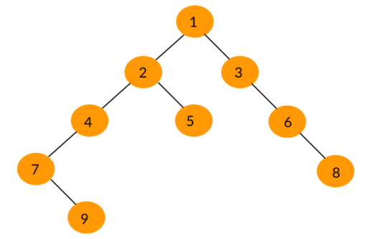Fig 2
Solution:
In order Traversal: 7, 9, 4, 2, 5, 1, 3, 6, 8
Preorder Traversal: 1, 2, 4, 7, 9, 5, 3, 6, 8
Post order Traversal: 9, 7, 4, 5, 2, 8, 6, 3, 1
EXAMPLE: Discuss all the three ways to traverse the binary tree shown below fig 3:
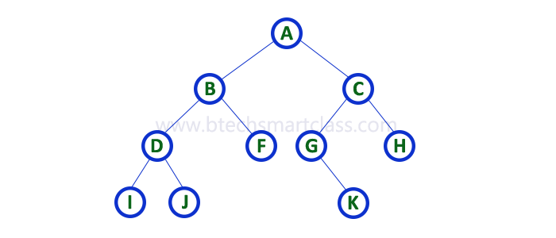Fig 3
Solution:

1. In - Order Traversal (left Child - root – right Child)
In In-Order traversal, the root node is visited between the left child and right child. In this traversal, the left child node is visited first, then the root node is visited and later we go for visiting the right child node. This in-order traversal is applicable for every root node of all sub trees in the tree. This is performed recursively for all nodes in the tree.
That means the in order traverse of given tree is I - D - J - B - F - A - G - K - C - H.

2. Pre - Order Traversal (root – left Child – right Child)
In Pre-Order traversal, the root node is visited before the left child and right child nodes. In this traversal, the root node is visited first, then its left child and later its right child. This pre-order traversal is applicable for every root node of all sub trees in the tree.
That means the pre order traverse of given tree is A-B-D-I-J-F-C-G-K-H.

3. Post - Order Traversal (left Child – right Child - root)
In Post-Order traversal, the root node is visited after left child and right child. In this traversal, left child node is visited first, then its right child and then its root node. This is recursively performed until the right most nodes are visited.
That means the pre order traverse of given tree is I - J - D - F - B - K - G - H - C – A

1.6Algorithms:
(a)Algorithm to draw a Unique Binary Tree when In order and Preorder Traversal of the tree is Given:
- We know that the root of the binary tree is the first node in its preorder. Draw the root of the tree.
- To find the left child of the root node, first, use the in order traversal to find the nodes in the left sub tree of the binary tree. (All the nodes that are left to the root node in the in order traversal are the nodes of the left sub tree). After that, the left child of the root is obtained by selecting the first node in the preorder traversal of the left sub tree. Draw the left child.
- In the same way, use the in order traversal to find the nodes in the right sub tree of the binary tree. Then the right child is obtained by selecting the first node in the preorder traversal of the right sub tree. Draw the right child.
- Repeat the steps 2 and 3 with each new node until every node is not visited in the preorder. Finally, we obtain a unique tree.
Example: Draw the unique binary tree when the in order and preorder traversal is given as in following table 1.1:
In order | B | A | D | C | F | E | J | H | K | G | I
Preorder | A | B | C | D | E | F | G | H | J | K | I
Table 1.1
Solution: We know that the root of the binary tree is the first node in preorder traversal. Now, check A, in the in order traversal, all the nodes that are of left A, are nodes of left sub tree and all the nodes that are right of A, are nodes of right sub tree. Read the next node in the preorder and check its position against the root node, if it’s left of the root node, then draw it as a left child, otherwise draw it a right child. Repeat the above process for each new node until all the nodes of the preorder traversal are read and finally we obtain the binary tree as shown in fig4
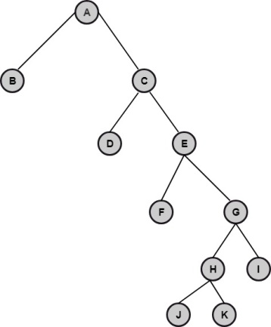Fig 4
(b) Algorithm to draw a Unique Binary Tree when In order and Post order Traversal of the tree is Given:
- We know that the root of the binary tree is the last node in its post order. Draw the root of the tree.
- To find the right child of the root node, first, use the in order traversal to find the nodes in the right sub tree of the binary tree. (All the nodes that are right to the root node in the in order traversal are the nodes of the right sub tree). After that, the right child of the root is obtained by selecting the last node in the post order traversal of the right sub tree. Draw the right child.
- In the same way, use the in order traversal to find the nodes in the left sub tree of the binary tree. Then the left child is obtained by selecting the last node in the post order traversal of the left sub tree. Draw the left child.
- Repeat the steps 2 and 3 with each new node until every node is not visited in the post order. After visiting the last node, we obtain a unique tree.
Example: Draw the unique binary tree for the given In order and Post order traversal as is given in following table 1.2

In order | 4 | 6 | 10 | 12 | 8 | 2 | 1 | 5 | 7 | 11 | 13 | 9 | 3
Post order | 12 | 10 | 8 | 6 | 4 | 2 | 13 | 11 | 9 | 7 | 5 | 3 | 1
Table 1.2
Solution: We know that the root of the binary tree is the last node in the post order traversal. Hence, one in the root node.
Now, check the in order traversal, we know that root is at the center, hence all the nodes that are left to the root node in in order traversal are the nodes of left sub tree and, all that are right to the root node are the nodes of the right sub tree.
Now, visit the next node from back in post order traversal and check its position in in order traversal, if it is on the left of root then draw it as left child and if it is on the right, then draw it as the right child.
Repeat the above process for each new node, and we obtain the binary tree as shown in fig5:
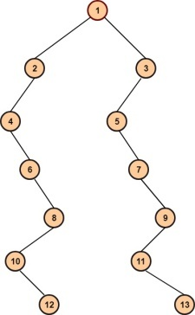 Fig 5
(c) Algorithm to convert General Tree into the binary tree
- Starting from the root node, the root of the tree is also the root of the binary tree.
- The first child C₁ (from left) of the root node in the tree is the left child C₁ of the root node in the binary tree, and the sibling of the C₁ is the right child of C₁ and so on.
- Repeat the step2 for each new node.
Example: Convert the following tree as shown in fig 6 into a binary tree.
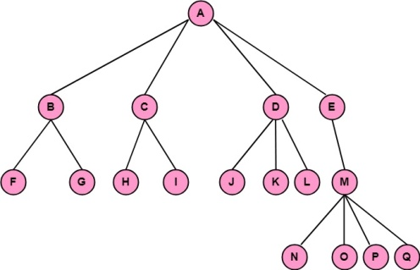
Fig 6
Solution: The root of the tree is the root of the binary tree. Hence A is the root of the binary tree. Now B becomes the left child of A in a binary tree, C becomes the right child of B, D becomes right child of C, and E becomes the right child of D in the binary tree and similarly applying the algorithm we obtain the binary tree as shown in fig 7:
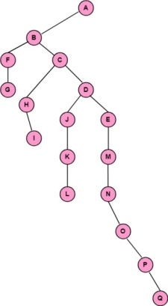
Fig 7
Summary
The points discussed in this lecture are summarized below:
- Displaying or visiting order of nodes in a binary tree is called Binary tree traversal.
- There are three standard methods to traverse a binary tree, In order, pre order, post order traversal.
- In In-Order traversal, the left child node is visited first, then the root node is visited and later we go for visiting the right child node.
- In Pre-Order traversal, the root node is visited first, then its left child and later its right child.
- In Post-Order traversal, left child node is visited first, then its right child and then its root node.
- Algorithm to draw a Unique Binary Tree when In order and Preorder Traversal of the tree is Given.
- Algorithm to draw a Unique Binary Tree when In order and Post order Traversal of the tree is Given.
- Algorithm to convert General Tree into the binary tree

Frequently asked questions
Q1 what is traversing in data structure?
ANS Traversing a data structure means: "visiting" or "touching" the elements of the structure, and doing something with the data. (Traversing is also sometimes called iterating over the data structure)

Q2 Why traversing is done?
ANS Traverse is a method in the field of surveying to establish control networks. It is also used in geodesy. ... Scale error does not add up as the traverse is performed. Azimuth swing errors can also be reduced by increasing the distance between stations.

REFERENCES

WEB LINKS

1http://www.btechsmartclass.com/data_structures/tree-terminology.html

2 https://www.slideshare.net/AdilAslam4/chapter-11-tree-in-discrete-mathematics

VIDEO LINKS
1 https://youtu.be/KlVNKEECLIc

2 https://youtu.be/H5JubkIy_p8

APPLICATIONS
Binary search trees are a fundamental data structure used to construct more abstract data structures such as sets, multi sets, and associative arrays. When inserting or searching for an element in a binary search tree, the key of each visited node has to be compared with the key of the element to be inserted or found.
PRACTICE QUESTIONS
Q1 Draw the unique binary tree if the following is given
In order traverse d b h e a f c I j g
Pre order traverse a b d e h c f g I j
Q2 Draw the unique binary tree if the following is given
In order traverse 4 6 10 12 8 2 1 5 7 11 13 9 3
Post order traverse 12 10 8 6 4 2 13 11 9 7 5 3 1

